SIMATS ENGINEERING
ASSESSMENT TOOL 2
COURSE NAME: CSA16 COURSE CODE: Data Warehousing and Data Mining

COURSE OUTCOME COVERED
CO4: Examine the applicability of clustering algorithms in real-world scenarios, presenting findings through clear reports with effective visualizations.
Assessment Tool Weightage: 20%

QUESTIONS: 05 Total Marks:50
Annexure A

COMPARITIVE ANALYSIS
Criteria | Scope of Items (2) | Comparison Depth(2.5) | Use of  Evidence  (2) | Critical  Thinking (2) | Clarity of  Presentation (1) | Total(10  )
Weightag e | 20% | 25% | 20% | 20% | 10% | 100%
Q1
Q2
Q3
Q4
Q5

Code of Conduct:
I Uppu Sye Kumar/192325121 (Name / Reg No) certify that this submission is my original work and that I have adhered to the guidelines specified for this assessment.
I understand that any violation of academic integrity rules will result in disciplinary action.
Signature of the student:
RUBRICS FOR CALCULATION:
 |  | Comparative analysis
Criteria | Weightag e (%) | Level 4 (Exemplary) | Level 3 (Proficient) | Level 2  (Developing  ) | Level 1 (Beginning)
Scope of Items | 20% | Selects highly relevant items with clear scope and justification | Selects appropriate items with minor gaps | Selection is limited or partially relevant | Items are unclear or not relevant
Compariso n Depth | 25% | Provides detailed and comprehensive comparison across multiple aspects | Provides adequate comparison with some depth | Limited comparison with few aspects | Very minimal or no comparison
Use of Evidence | 20% | Supports comparison with accurate data, examples, or references | Uses some supporting evidence with minor gaps | Limited or weak supporting evidence | No supporting evidence provided
Critical Thinking | 20% | Demonstrates strong critical thinking with clear interpretation and reasoning | Shows reasonable interpretation with minor gaps | Basic interpretatio  n; lacks depth | No meaningful  interpretatio  n
Clarity of Presentatio n | 15% | Well-organized, clear, and logically structured presentation | Generally clear with minor issues | Somewhat  unclear or poorly structured | Disorganize d and  difficult to  understand

Annexure A
Q1 . Dataset: Assessment Tool 2: Comparative Analysis (25% → 5
Marks)
Time duration :45 Minutes Assessment Tool 3 (Low)
Q1 . Dataset: Customer Data Customer Income (₹) Spending Score
C1 30000 60
C2 60000 40
C3 50000 70
C4 28000 65
C5 65000 35
Question:
Compare K-means and hierarchical clustering using this dataset and explain differences in performance and scalability. (BL3 – 1 Mark)

CUSTOMER DATA
Comparison of K-Means and Hierarchical Clustering
1. Dataset
Customer | Income (₹) | Spending Score
C1 | 30,000 | 60
C2 | 60,000 | 40
C3 | 50,000 | 70
C4 | 28,000 | 65
C5 | 65,000 | 35

2. Data Interpretation
The dataset contains two important customer characteristics:
- Customer Income: Financial capacity of the customer.
- Spending Score: Indicates the customer's purchasing behavior.
Based on the values, the customers can broadly be grouped as follows:
Customer Group | Customers | General Pattern
Low Income / High Spending | C1, C4 | Lower income but active spending
High Income / Low Spending | C2, C5 | Higher income but relatively lower spending
High Income / High Spending | C3 | Good income and high spending

3. K-Means Clustering
K-Means is a centroid-based clustering algorithm. It divides the data into a predefined number of clusters.
Working Process
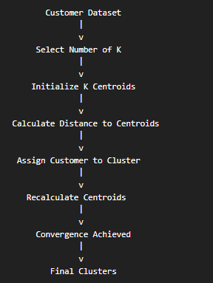
Possible Result for K = 3
Cluster | Customers | Interpretation
Cluster 1 | C1, C4 | Lower income and higher spending
Cluster 2 | C2, C5 | Higher income and lower spending
Cluster 3 | C3 | High spending customer

4. Hierarchical Clustering
Hierarchical clustering creates a hierarchy of clusters instead of directly fixing the number of clusters.
For this dataset, similar customers can be merged step by step.
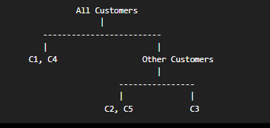
A dendrogram can be cut at different levels to obtain different numbers of clusters.

5. Comparative Analysis
Aspect | K-Means | Hierarchical Clustering
Basic Approach | Centroid-based | Tree-based
Number of Clusters | Must specify K in advance | Can decide clusters from dendrogram
Scalability | High | Lower for large datasets
Speed | Generally faster | Generally slower

6. Performance and Scalability
K-Means
Advantages:
- Fast for large datasets.
- Requires less memory.
- Easy to implement.
- Suitable for large customer databases.
Limitations:
- K must be selected before clustering.
- Sensitive to initial centroids.
- Sensitive to outliers.
Hierarchical Clustering
Advantages:
- Does not require fixing K initially.
- Provides a dendrogram.
- Helps understand relationships between customers.
Limitations:
- Computationally expensive.
- Requires more memory.
- Less suitable for very large customer datasets.
Conclusion
For this small dataset, both algorithms can provide useful customer segments. However, hierarchical clustering gives more insight into the relationship between customers, while K-Means is better for performance and scalability.
Q2. Dataset: Document Data
Document Word1 Word2 Word3
D1 0.2 0.5 0.3
D2 0.1 0.6 0.3
D3 0.8 0.1 0.1
D4 0.75 0.15 0.1
D5 0.2 0.4 0.4
Question:
Compare K-means and EM algorithms in handling overlapping clusters for the given dataset. (BL4 – 1 Mark)
Data Interpretation
Documents D1, D2, and D5 have relatively high values for Word2 and Word3.
Documents D3 and D4 have high values for Word1.
Therefore, two main document groups can be identified:
Cluster A Cluster B
------------ ------------
D1 D3
D2 D4
D5

High Word2/Word3 High Word1
However, D5 has values that may partially overlap with another group.

3. K-Means Algorithm
K-Means performs hard clustering.
Each document belongs to exactly one cluster.
Example:
Document | K-Means Assignment
D1 | Cluster 1
D2 | Cluster 1
D3 | Cluster 2
D4 | Cluster 2
D5 | Cluster 1
Document
|
v
Calculate Nearest Centroid
|
v
Assign to ONE Cluster Only
Limitation
A document with mixed word patterns must still be assigned to only one cluster.

4. EM Algorithm
The Expectation-Maximization (EM) algorithm uses probability-based membership.
A document can have a probability of belonging to multiple clusters.
Example:
Document | Probability: Cluster 1 | Probability: Cluster 2
D1 | 0.90 | 0.10
D2 | 0.95 | 0.05
D3 | 0.05 | 0.95
D4 | 0.08 | 0.92
D5 | 0.70 | 0.30
For D5:
This shows that D5 has characteristics of both groups.
5. Comparison
Aspect | K-Means | EM Algorithm
Cluster Assignment | Hard | Soft / Probabilistic
Membership | One cluster only | Can belong to multiple clusters
Overlapping Data | Less effective | More effective
Output | Cluster labels | Cluster probabilities
Model | Centroid-based | Probability distribution-based
Complexity | Lower | Higher
Execution Speed | Faster | Usually slower

6. Conclusion
K-Means is suitable when document groups are clearly separated.
The EM algorithm is more suitable when documents contain overlapping word patterns. Since real documents may contain multiple topics, EM provides a more flexible and realistic representation.
Q3. Dataset: Geographic Data
Point Latitude Longitude
P1 13.08 80.27
P2 13.10 80.25
P3 12.97 80.22
P4 13.05 80.30
P5 13.00 80.20
Question:
Compare Euclidean and Manhattan distance metrics and analyze their impact on clustering results. (BL4 – 1 Mark)
GEOGRAPHIC DATA
Comparison of Euclidean and Manhattan Distance
1. Dataset
Point | Latitude | Longitude
P1 | 13.08 | 80.27
P2 | 13.10 | 80.25
P3 | 12.97 | 80.22
P4 | 13.05 | 80.30
P5 | 13.00 | 80.20

2. Euclidean Distance
Euclidean distance measures the straight-line distance.
Example: P1 and P2
3. Manhattan Distance
Manhattan distance measures the total movement along individual dimensions.
Example: P1 and P2

4. Comparison
Aspect | Euclidean Distance | Manhattan Distance
Measurement | Straight-line distance | Sum of horizontal and vertical differences
Formula | √[(x₂−x₁)²+(y₂−y₁)²] | |x₂−x₁|+|y₂−y₁|
Geometric Shape | Circular | Diamond-shaped
Suitable For | Direct spatial distance | Grid-like movement
Sensitivity | Sensitive to large differences | Less affected by individual large differences
Geographic Interpretation | Approximate direct closeness | Axis-based closeness

5. Impact on Clustering
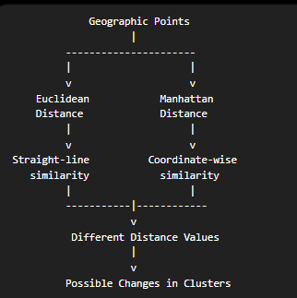
For this dataset:
- P1, P2, and P4 are geographically close.
- P3 and P5 form another nearby group.
Both metrics may identify similar major groups, but the distance values and cluster boundaries can differ.
Conclusion
Euclidean distance is more suitable when straight-line geographic proximity is important. Manhattan distance is more suitable when movement follows grid-based paths.
For latitude and longitude clustering, Euclidean distance can be used as an approximation for small geographic areas.

Q4. Dataset: Retail Products Product Sales (₹) Frequency
P1 | 50000 | 20
P2 | 30000 | 10
P3 | 52000 | 22
P4 | 25000 | 8
P5 | 32000 | 12
Question:
Compare agglomerative and divisive clustering approaches and explain their suitability for this dataset. (BL3 – 1 Mark)
RETAIL PRODUCTS
Comparison of Agglomerative and Divisive Clustering
1. Dataset
Product | Sales (₹) | Frequency
P1 | 50,000 | 20
P2 | 30,000 | 10
P3 | 52,000 | 22
P4 | 25,000 | 8
P5 | 32,000 | 12

2. Data Interpretation
Products can be broadly divided into two groups:
High Sales and High Frequency
- P1
- P3
Moderate or Low Sales and Frequency
- P2
- P4
- P5

3. Agglomerative Clustering
Agglomerative clustering follows a bottom-up approach.
Initially, every product is considered an individual cluster.
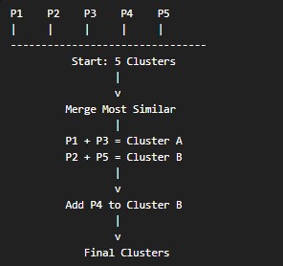
Result
Cluster | Products
Cluster A | P1, P3
Cluster B | P2, P4, P5

4. Divisive Clustering
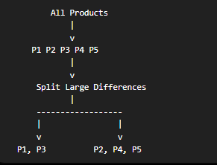
5. Comparison
Aspect | Agglomerative | Divisive
Approach | Bottom-up | Top-down
Starting Point | Each item is one cluster | All items form one cluster
Main Operation | Merge clusters | Split clusters
Process | Builds hierarchy | Divides hierarchy
Common Usage | More common | Less common
Computation | Can be expensive | Often more complex
Dataset Suitability | Good for small datasets | Good for understanding major splits

6. Suitability for This Dataset
The dataset contains only five products.
Agglomerative clustering is suitable because:
- Similar products can be easily merged.
- P1 and P3 have very similar sales and frequency.
- P2 and P5 are also relatively similar.
- The cluster hierarchy is easy to understand.
Divisive clustering can identify the major split between:
- High-performing products.
- Lower-performing products.
Conclusion
Both approaches are useful. However:
It clearly groups similar products based on sales and purchase frequency.

Q5 . Dataset: Mixed Attributes Item Price (₹) Category Rating
I1 | 500 | A | 4.5
I2 | 300 | B | 3.8
I3 | 550 | A | 4.7
I4 | 250 | B | 3.5
I5 | 520 | A | 4.6
Question:
Compare centroid-based and density-based clustering techniques and analyze their effectiveness on mixed data types. (BL4 – 1 Mark)

MIXED ATTRIBUTES
Comparison of Centroid-Based and Density-Based Clustering
1. Dataset
Item | Price (₹) | Category | Rating
I1 | 500 | A | 4.5
I2 | 300 | B | 3.8
I3 | 550 | A | 4.7
I4 | 250 | B | 3.5
I5 | 520 | A | 4.6

2. Data Interpretation
The dataset contains:
- Numerical Attribute: Price.
- Categorical Attribute: Category.
- Numerical Attribute: Rating.
The items naturally show two major patterns.
Group A
I1, I3, and I5:
- Category A.
- Higher prices.
- Higher ratings.
Group B
I2 and I4:
- Category B.
- Lower prices.
- Lower ratings.

3. Centroid-Based Clustering
K-Means is a common centroid-based clustering technique.

Working
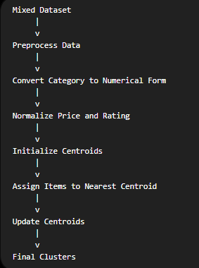
Important Limitation
K-Means cannot directly process categorical data such as A and B.
Therefore, the data must be converted or another method such as K-Prototypes may be used.

4. Density-Based Clustering
A density-based technique such as DBSCAN identifies areas containing a high concentration of data points.
It can:
- Identify dense groups.
- Detect outliers.
- Handle irregular cluster shapes.
- Avoid requiring K in advance.
However, mixed attributes require an appropriate similarity measure before density-based clustering is applied.

5. Comparison
Aspect | Centroid-Based Clustering | Density-Based Clustering
Example Algorithm | K-Means | DBSCAN
Cluster Formation | Around centroid | Based on dense regions
Need K in Advance | Yes | No
Outlier Detection | Poor | Strong
Cluster Shape | Best for spherical clusters | Can handle arbitrary shapes
Mixed Attributes | Requires preprocessing | Requires suitable distance measure
Sensitivity | Sensitive to outliers | Sensitive to density parameters
Large Dataset | Generally efficient | Depends on data structure

6. Effectiveness for the Given Dataset
Centroid-Based Method
After encoding and normalization:
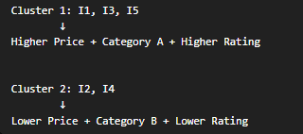
It is effective because the dataset has clearly separated groups.

Density-Based Method
DBSCAN may also identify two dense groups, but this dataset contains only five points.
Therefore, selecting parameters such as epsilon (ε) and MinPts may be difficult and sensitive.
Conclusion
For this small dataset with clearly separated groups:
For larger datasets containing irregular clusters and outliers, density-based clustering would provide greater advantages.

